

**RailTech Innovations**

1455 Blvd. De Maisonneuve Ouest, Montréal, Québec H3G 1M8

April 16th, 2024

Direction générale du transport terrestre des personnes - Ministère du transport et de la mobilité durable du Québec.

700, boulevard René-Lévesque Est, 15e étage

Montréal (Quebec) G1R 5H1

Dear Ms. Elena Crestwood,

In response to the growing demand for reliable mobility in Quebec, and the urgent need to address the repercussions of climate change on our local communities, RailTech innovations team has developed a comprehensive proposal that will help alleviate the pressure on the transportation sector, without compromising the commitment that the government has made to reduce its environmental impact. The report attached contains a plan that utilizes a new technology in the railway called magnetic levitation in order to propose an alternative to the existing fossil fuel dependent methods of transportation, primarily within the rail network.

The report consists of a comprehensive analysis of the escalating demand for transportation infrastructure and its profound implications on the environment, and the benefits of implementing this technology that will, based on our research, address your concerns. Our analysis supports the government’s view that transportation contributes considerably to our province’s emissions of greenhouse gases, and that the fast population growth will put the existing infrastructure under bigger pressure over time. Based on our team’s research, we propose a novel rail technology that will eliminate the use of fossil fuel, therefore addressing the emissions concerns, yet be a realistic alternative to both the aviation and automobile industries. We have included a detailed outline for a plan of action in the report for your review.

We express our gratitude for the confidence you’ve placed in our team to conduct this research and present our findings. At RailTech innovations, we are fully equipped to address any concerns, questions, or comments you may have regarding this proposal. We would like the opportunity to present the project in person to provide clarity, insights, and solutions to ensure its effectiveness and success. You can reach the team through me, at [m.kerir@rtinnovations.ca](mailto:m.kerir@rtinnovations.ca). We look forward to our collaboration.

Sincerely,



Mohamed KERIR

Enclosure: Maglev: An Efficient and Eco-Friendly Solution to our Transport Needs

**Maglev: An Efficient and Eco-Friendly Solution to our Transport Needs**

**Proposal for**

**Maglev Train, Montreal to Ottawa**

**Prepared for**

**Direction générale du transport terrestre des personnes - Ministère du transport et de la mobilité durable du Québec**

**Prepared by**

**Mohamed Kerir (40262213)**

**Karan Kumar (40277342)**

**Marcus Sharma (40240069)**

**Nathan Wong (40274889)**

**Quoc Vinh Ta (40284935)**

**April 16th, 2024**

**Table of Contents**

Table of Contents ............................................................................................................................... i  
Table of Figures ................................................................................................................................. ii  
Executive Summary ........................................................................................................................... 1   
 Problem Statement ................................................................................................................ 1  
 Proposed Solution ................................................................................................................. 1   
 Benefits ................................................................................................................................. 1   
 Final Thoughts and Next Steps ............................................................................................. 1 Introduction......................................................................................................................................... 2  
 Statement of Problem............................................................................................................. 2   
 GHG emissions from the transportation sector...................................................................... 3   
 GHG emissions from Railway............................................................................................... 3   
 Air Pollution from Railway................................................................................................... 4   
 Waste Produced by Railway.................................................................................................. 4  
 Noise Pollution...................................................................................................................... 5  
Potential Solutions.............................................................................................................................. 5   
 Electric trains.………............................................................................................................ 5   
 Electric buses......................................................................................................................... 5   
 Magnetic levitating trains...................................................................................................... 6   
The Proposed Plan ............................................................................................................................. 7  
 The plan ................................................................................................................................ 7   
 Implementation of the Maglev train...................................................................................... 7   
 Proposed schedule.................................................................................................................. 8   
Budget................................................................................................................................................. 8  
 Total approximate cost........................................................................................................... 8   
 Planning................................................................................................................................. 9  
 Research................................................................................................................................. 9   
 Design.................................................................................................................................... 9   
 Implementation ......................................................................................................................9

Follow Up .......................................................................................................................................... 9  
Team Qualifications............................................................................................................................ 11   
Conclusion ......................................................................................................................................... 12   
References........................................................................................................................................... 14

# **List of figures**

Figure 1 Total transportation greenhouse gas emissions from all modes, 2000 to 2019.................... 3

Figure 2 Map of Via Rail Corridor..................................................................................................... 7

Figure 3 Gantt chart visualization of timeline 2025-2042.................................................................. 8   
Table 1 Cost and sub costs of each stage............................................................................................ 10

# 

# 

# 

# 

# 

# 

# 

# 

# 

# 

# **Executive Summary**

## Problem Statement

With Canada being one of the top greenhouse gas emitters per capita it is essential that Canadians make an effort to reduce their carbon footprint [1]. One of the top emitters of greenhouse gases and waste is the transportation sector, accounting for 28% of the country’s total emissions [2]. In 2021, the railway sector represented 4.2% of Canada’s transport related greenhouse gas emissions [1]. A more efficient and eco-friendly solution to a commuter’s transport needs is necessary to solve this issue.

**Proposed Solution**

RailTech Innovations is proposing an investment in magnetic levitation technology within the system of trains to transport people for long and medium distances, such as inter-city or interprovincial transit. More specifically, the new network would start with a line between Montreal and Ottawa, with the potential to eventually become a cross-country mass transport rail network.

**Benefits**

As technology advances, Maglev trains move more smoothly and quietly than their wheeled counterparts. By eliminating friction against the rails, Maglev trains can achieve very high speeds only comparable to aviation, as well as high energy efficiency ratios, with only air drag to counter. On top of this, these trains are less wasteful than other forms of transport since they require no mineral oils for lubrication, and very little maintenance, producing practically no form of refuse [3].

**Final Thoughts and Next Steps**

Maglev trains are an overall superior solution to other forms of transport especially within the rail sector, and Quebec’s government should consider implementing the technology to move towards a greener future. This will inevitably incite other government entities to consider this innovation as a viable solution to our shared problem.

# 

# **Introduction**

# Environmental concerns are growing bigger by the hour, which prompts significant questions about our consumption patterns, mobility, and how we interact with the planet. Transportation is a major source of emissions; this sector alone contributes to 26% of global CO2 emissions [4]. As one of the major transportation methods, the railway has been present since the nineteenth century, it is responsible for accelerating the industrial revolution, and facilitating transportation of goods and people since then. However, the use of coal in steam engines, and subsequently diesel in more modern locomotives, has proven detrimental on various fronts [5]. Aside from the GHG emissions, conventional rail generates considerable amounts of particulate matter into the air, waste from frequently needed maintenance, and auditory disturbance. However, considering its benefits, introducing a novel promising technology in rail will alter the discourse surrounding this sector. Maglev, or magnetic levitation, is a technology that consists of the controlled suspension or levitation of an object through magnetic repulsion and attraction [6]. Maglev trains harvest this technology, and they represent a significant advancement in the transportation sector, leveraging magnetic forces to levitate above the ground, propel, and decelerate. This essential distinction from conventional trains allows them to run frictionless, providing a smoother and more efficient journey. The interaction between the train’s magnets and the coils installed in the track is the key to its levitation [1]. The incorporation of Maglev trains into the transportation network as seen with the EMS Chinese model has demonstrated the technology’s significant environmental and socio-economic benefits [9]. The proposed plan is on a provincial scale and has the potential to grow into the national scope. As technology advances, and the need for greener transportation alternatives grows, Maglev trains stand as a realistic candidate to be considered.

# **Statement of Problem**

# Pollution, especially air pollution, is at an all-time high globally with, yet no prospect of decreasing. While greenhouse gas emissions are the main cause of concern, there are many other elements appearing which need relevant attention. In the context of transportation, the railway system is shown to be one of the greenest modes of transportation. However, it still presents some flaws when it comes to its emissions. Not only is it a contributor of greenhouse gases, but some by-products from its usage can also be harmful to humans. With new technology on the rise, the necessity for investigating solutions for existing railway systems is a major component for a greener future.

**GHG Emissions From The Transportation Sector**  
The main producer of greenhouse gas emissions in the transport sector is not trains though. Road transportation is the main contributor to greenhouse gas emissions, as seen in the figure below [10]. Commuters are more likely to choose car or plane transport to get from city to city than rail. People choose these less energy efficient and wasteful modes of transport because they prioritize comfort and practicality. This is shown by the main increase in greenhouse gases coming from people choosing light trucks over smaller and efficient modes of transport [11]. This problem has lingered for years, and the right solution has not yet been found. Consumers want a comfortable and fast answer to their transportation needs, and something must be done to find an eco-friendly solution to this desire.

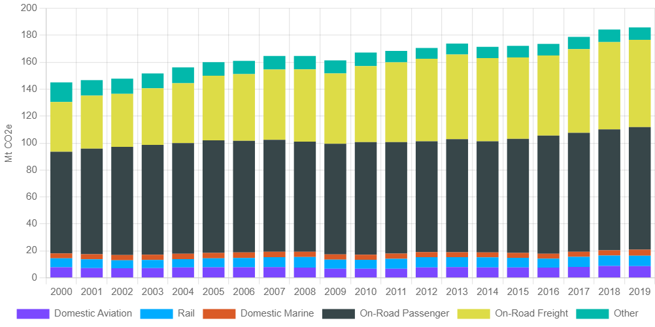  
Figure 1: Total transportation greenhouse gas emissions from all modes, 2000 to 2019 [12]

**GHG Emissions From Railway**  
Train transportation in its current state is not as efficient as it could be. While it may not be a major contributor, its emissions are still considerable and unnecessary. Emissions produced by the train sector could be reduced by introducing efficient and eco-friendly alternatives to the locomotive train. Canada’s greenhouse gas emissions are increasing. From 2000 to 2019 greenhouse gas emissions from the transport sector went up from 144.95 Mt to 185.78 Mt [12]. Rail emissions increased from 6.66Mt to 7.77Mt in this same interval. By using more efficient methods of rail transport it would be possible to completely eliminate these emissions.

## Air Pollution From Railway

Not only do railway systems emit greenhouse gases, but they also contribute to the emission of airborne particulate matter. The air pollution that comes with trains comes from two sources. First, it is due to the wear and tear of the railway and brake system. Due to friction, the rails, and brakes, over time, slowly generate fine particulate material which can become airborne [13]. Furthermore, enclosed train stations make it a perfect environment for the accumulation of matter and expose many to high concentrations of particles [14]. While mainly composed of heavy metals, other materials can be found amongst its composition such as soot, soil, and dust.

Secondly, the other source of air pollution would be the engine fuel. Diesel powered trains are shown to be extremely pollutant. These trains can emit ultrafine particulates and black carbon, otherwise known as soot, have been shown to be a possible carcinogen to humans. With constant exposure to these harmful emissions, this can lead to major health degradation [15]. With a grand majority of these particles having a diameter of 2.5 microns or fewer, they impose a great risk to human health. Air pollution, such as particulate matter, has been responsible for premature death of humans around the world. With one out of nine deaths being caused by the exposure to pollutants in the air [16]. From different studies, there is evidence that these airborne particles had numerous effects on human health such as respiratory disease, cardiovascular disease, stroke, lung disease and many more negative impacts [17], [18].

# **Waste Produced by Railway**

Another important element, when it comes to the railway system, is the amount of waste that is produced. Rail tracks require a lot of maintenance and often need replacement. All the maintenance and replacement work on the trails and trains can generate large amounts of waste. While most of the material can be reused for other purposes, there are still a considerable amount of waste products that are sent to landfills. This can present an important ecological risk to the surrounding environment [19]. Taking a look at the Yun-Gui railway, it was estimated to have generated over 243 million tons of waste throughout its life cycle. For a single railway system, this is an enormous amount that poses a large risk [20]. Furthermore, if we consider the elimination process of waste material in landfill, these only contribute more to the overall greenhouse gas emission in the world.

Another element to consider are the industrial activities that come into play when there is work done on the railway system. Modern train rails often use cement for many rail components. Research on cement manufacturing, it was found that the cement manufacturing sector was responsible for 7% of the global CO2 emission in the environment. In fact, industrial activities can be shown to be quite harmful due to the by-product it can produce [19].

**Noise Pollution**

One more important aspect to consider is the noise pollution induced by the trains. Sound emitted by rails can reach up to 100 dB. Noise above 55 dB is considered, and anything above 75 dB can be harmful to humans. Train noise is mostly troubling in heavily urbanized areas and can negatively impact human health. It can lead to hypertension, cardiovascular disease, stress, sleep problems, heart attacks and many more detrimental health effects. Another problematic element is the transmission of low-frequency vibrations throughout the ground during the passage of the trains, also known as ground-borne vibrations. In some studies, there was a possible long-term effect on cardiovascular function. Those vibrations were also shown to degrade infrastructure in the vicinity of those tracks [21]. As much negative impact noise pollution can have on humans, they also can affect the surrounding wildlife. Some effects can range from disturbing their natural behavior to an increased mortality rate [22].

# **Potential Solutions**

**Electric Trains**

Most modern trains are developed using electric train technology. For example, the REM in Montreal is a new train development using high speed rail (Electric Train) technology. The technology is great, it offers a high speed eco-friendly and renewable solution to our traditional trains. But in all these categories the improvements are not very large compared to our current rails. High speed rail is only capable of traveling up to speeds of 400 km/h which is only a 160% improvement to diesel trains [23]. It is also only 175% more energy efficient than our current locomotive trains [24]. These improvements may seem large, but they are not worth it when comparing them to the improvements that maglev technology offers.

**Electric Buses**

An alternative solution to the problem was electric buses. Electric buses are a good solution to transportation in many situations. They’re flexible since they are not bound to a track and require no additional infrastructure since they are capable of using our current roads. But they lack many features that are important. Mainly electric buses do not improve much on energy efficiency, they are only 125% more efficient than diesel trains [25]. Moreover, these buses require wasteful and expensive batteries to operate. On top of this, they are not nearly as fast as the other alternatives. For all these reasons, electric buses are not the solution to the problem.

**Magnetic Levitation Trains**

# Maglev trains are far more efficient than the traditional locomotive train. One study determined that maglev trains can significantly reduce the energy intensity per passenger [6]. Energy intensity is a measure of how much energy it takes to achieve a certain task, in this case the study is measuring J/Km for each passenger. The study deduced that maglev reduces EI by about 50% when compared to rail transit and by about 23% percent when compared to high-speed rail transit. This means maglev trains require less energy, and therefore they use less fossil fuels. To add to this, their reduced consumption of fuel means they produce less air pollution as well, and possibly none at all when using energy sources like hydro.

# Not only are maglev trains energy efficient, but they are also very fast. These trains can reach speeds of about 600 Km/h [7]. A major limitation for their speed is air resistance, but in low pressure tubes this issue can be solved. In these tubes called hyperloops the train can reach speeds of about 1500 km/h [8]. This is much faster than the average commercial plane and far more eco-friendly. This means that maglev trains can create cheaper, more efficient, and more sustainable methods of transportation. This will drive more commuters to use these technologies and reduce the carbon emissions from cars and planes, two of the greatest contributors of carbon emissions in transportation.

# Due to their frictionless technology, these trains also don’t require any replacement of wheels, rails, or engines. The trains are simple empty passenger carts. This means they are easier to produce, and they reduce waste from the replacement of parts [26]. This technology also means they produce no noise from friction, which means these trains will reduce the effect that trains have on the surrounding wildlife.

# Though, even with all these advantages, the major setback to maglev trains are their high infrastructure costs. Maglev trains are just starting to become affordable, but require good planning and research, otherwise implementing these trains would be far too expensive for the benefits they offer. The magnetic levitation technology is inherently incompatible with existing rail infrastructure, their implementation would require an investment in the construction of dedicated tracks and any plans for expansion would require additional resources.

# 

# 

# **The Proposed Plan**

The RailTech Innovations’ team plans on constructing a maglev rail system along the current rail system route between Montreal and Ottawa, with the potential to expand it in the future. The reason for going along the existing route is to avoid additional excavation costs and to make use of any useful and existing infrastructure. Planning will commence in 2025 and after some years of research and designing the project could commence construction. The train will be complete and ready for passengers in the year 2040.

Figure 2. Map of Via Rail Corridor [27]

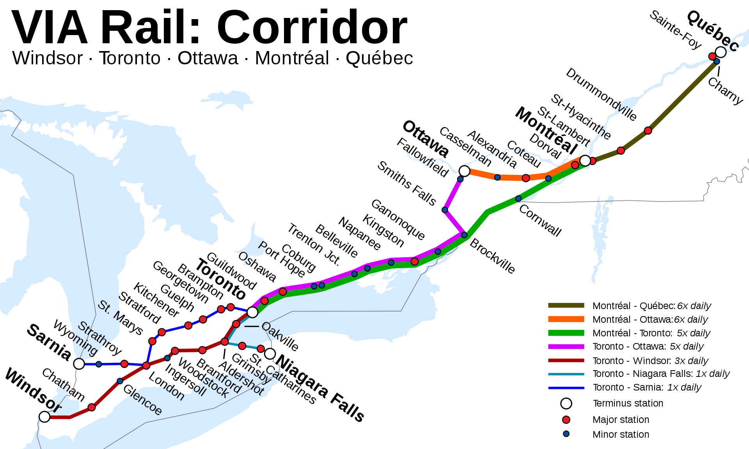

# **Implementation of a Maglev Train**

This proposal plans on implementing a MAGLEV train system from Montreal to Ottawa. The final goal is to reach a net-zero emission and greatly reduce travel time between these cities. The train will start in Gare-central in Montreal and arrive at the Ottawa train station. In Montreal, the Gare-Central is connected with the orange line of the metro system and in Ottawa the train station is connected with the lines 1 and 3 of the O-train making commuting in those cities easier once the trip with the MAGLEV is completed.[28] The proposal plans to start with the planning part as soon as possible, by the end of this year (2024) if possible and the implementation of the MAGLEV system should be done by the end of the year 2040.

## 

## 

## Proposed Schedule

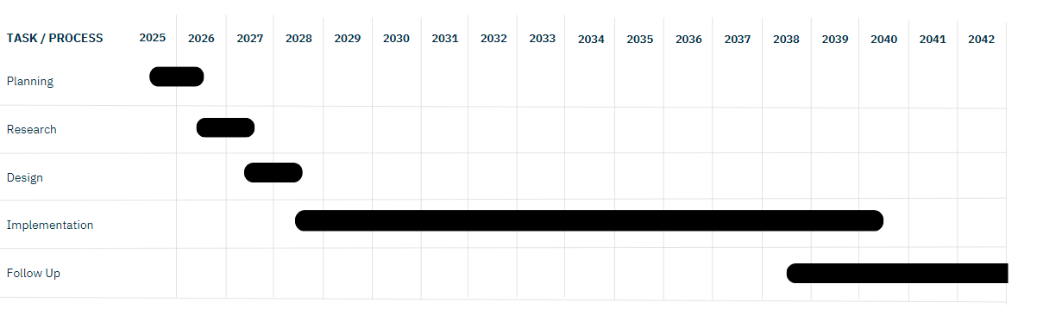Figure 3. Gantt chart visualization of timeline 2025-2042

As seen in the figure above, the main part of the proposed schedule is the actual implementation of the train. The implementation includes the construction of the train tracks and the rest of the structure needed for the train to be fully functioning. Of course, this proposed plan will start with a planning and a research part where more in debt research will be made on the harsh Canadian climate conditions and then a design will be made in function of the results of that research. Then the proposal will start its most massive part which is the implementation, that part is set to take 12 years. That part of the proposal is based on the MAGLEV project that already exists in Japan for the train from Tokyo to Nagoya. The distance from Montreal to Ottawa is about two-thirds of the distance from Tokyo to Nagoya and the train that connects these two cities is going to take an estimate of 15 years to build.[29] Two-thirds of that is going to be 10 years but since construction in Canada is much slower than the one in Japan for several reasons anywhere from the weather to the actual construction staff, the proposal provides a generous headroom of 2 years. Once the implementation is done, the crew has to make sure that everything is in optimal shape for the comfort of the users. For this reason, the proposed plan also includes a follow-up period which will end once the clientele is satisfied with the service. Maintenance and such essential follow ups will continue even once the follow up is done.

## Budget

**Total approximate cost**  
Budgeting is a very important part of the construction of a system like the MAGLEV that will be implemented from Montreal to Ottawa. The budget for this proposal is set to be about 47.136 billion dollars. From that, a huge part, almost all of it, 47.100 billion dollars are allocated to the construction of the actual train tracks and the actual train.

**Planning**The budget of 5 million for that part comes from the salaries for our employees and the location of the infrastructure where we will meet and other essential company expenses. Another important part of the expenses for this task are the hiring campaigns that will be conducted in order to have the right staff

**Research**The budget of 11,110 million for this part is going to be used mainly towards problem solving. The main problems this proposal has to attack are the harsh Canadian weather conditions consisting of very cold winters [30]. The reason the budget is so important for the solving part is because the proposal needs to actually test the solutions in real world condition and not just theorize it in order to be ready for the design and implementation.

**Design**The budget of 18.610 million for this part of the proposal is going mainly for the engineering of the tracks. It is important for the engineering to be top notch for the user of this MAGLEV system to have the smoothest possible experience.

**Implementation**This part of the proposal is the one with the most important budget, 47.100 billion dollars. This part is the most important due to the high price of implementation of a MAGLEV train system. The cost comes from the high cost of materials. For the calculation of these prices the proposal is based on an estimate made by the US. The cost was estimated to be about 100 million USD for one mile of track. The distance is the one mentioned in the implantation, the one from Gare-Central (in Montreal) to the train station in the center of Ottawa.[31]

**Follow up**The 1.250 million that are planned for this part will come from labor to make sure that the train is up to standards and satisfies its clientele.

|  |  |  |  |  |
| --- | --- | --- | --- | --- |
| **Task** | **Labor** | **Materials** | **Other** | **Total** |
| **Planning** | 5 000 000 $ | 0 $ | 0 $ | 5 000 000 $ |
| Hiring | 5 000 000 $ | 0 $ | 0 $ | 5 000 000 $ |
| **Research** | 10 000 000 $ | 1 000 000 $ | 110 000 $ | 11 110 000 $ |
| Gathering Information | 2 000 000 $ | 0 $ | 10 000 $ | 2 010 000 $ |
| Solving Problems | 8 000 000 $ | 1 000 000 $ | 100 000 $ | 9 100 000 $ |
| **Design** | 18 000 000 $ | 500 000 $ | 110 000 $ | 18 610 000 $ |
| Planning Path | 1 000 000 $ | 0 $ | 50 000 $ | 1 050 000 $ |
| Planning Materials | 2 000 000 $ | 0 $ | 10 000 $ | 2 010 000 $ |
| Engineering Train/Rails | 15 000 000 $ | 500 000 $ | 50 000 $ | 15 550 000 $ |
| **Implementation** | 2 100 000 000 $ | 45 000 000 000 $ | 0 $ | 47 100 000 000 $ |
| Building The Train | 100 000 000 $ | 3 000 000 000 $ | 0 $ | 3 100 000 000 $ |
| Laying Out The Rail | 2 000 000 000 $ | 42 000 000 000 $ | 0 $ | 44 000 000 000 $ |
| **Follow Up** | 1 200 000 $ | 0 $ | 50 000 $ | 1 250 000 $ |
| Inspection | 1 200 000 $ | 0 $ | 50 000 $ | 1 250 000 $ |

Table 1. Cost and sub costs of each stage

## Team Qualifications

At RailTech Innovations, every member of our team is dedicated to delivering cutting-edge solutions tailored to your needs. Our team is composed of highly qualified professionals with diverse expertise along different fields. Our engineers along with management and communications experts are the driving force behind our innovative solutions.[32]

**Mohamed KERIR**

* Bachelor’s in business technology management, University of Waterloo.
* Master of business administration, Concordia University.

With a strategic vision and meticulous attention to detail, Mohamed, our technical team manager, brings a wealth of experience and expertise to the table. His contribution to the success of many of our projects proves his worth and his dedication to surpassing complex technical management challenges. As the project manager, he will walk you through every step of the way, fostering clear communication and transparency, and diligently managing important timelines and resources. Mohamed will head the planning phase and will be managing various teams throughout the other phases.

**Nathan WONG**

* Bachelor’s in civil engineering, University of Toronto.
* Master’s in transportation engineering, McGill University.

Nathan’s expertise in transportation as a civil engineer is a key pillar of this project. His prior work in projects of national scale has earned him a valuable role within our organization. His deep understanding of traffic flow dynamics, infrastructure design principles, and sustainable transportation principles will be an important asset for the success of your project. Nathan will head the design phase and help out with the research phase.

**Marcus SHARMA**

* Bachelor’s in mechanical engineering, York University.
* Master’s in railway systems engineering and integration, University of Birmingham.

With a specialization in Railway Systems engineering, Marcus brings a wealth of hands-on experience in the focus of systems and systems integration within the rail network. His comprehensive understanding of propulsion, dynamic systems, and safety regulations positions him as a driving force in the success of your project. Marcus will head the research phase and help with the design phase.

**Karan KUMAR**

* Bachelor’s in electrical engineering, British Columbia institute of technology.
* Master’s in electrical and computer engineering, Concordia University.

Karan's unique fusion of electrical engineering principles and computer technology puts him at the forefront of our project. His contributions to enhance the dynamic levitation using superconducting magnets within the scope of scientific research makes him a pillar in the field. His proficiency extends to developing computer algorithms and software solutions that are essential to the success of this project. Karan will play key roles in both the design and research phase.

**Quoc Vinh TA**

* Bachelor’s in technical communications, University of Calgary.
* Master of business administration, Western University.

Vinh’s expertise in management and effective communication is a key asset of our team. With his understanding of market analysis, and business management, he ensures that the project resonates with private investors, associated public institutions, and the wider public. Vinh will be responsible for all communications aspects of the project, to keep you and all the project’s associates up to date with the progress. For a project of this scale, his role will come into play with strong advocacy to drive its visibility, credibility, and ultimately, its success. Vinh will head the follow-up phase as well as the implementation phase of the project.

# **Conclusion**

The rail network is an important logistical tool, providing private and public enterprises with a reliable, and affordable way of transporting goods and people. Yet the environmental concerns about emissions of fossil fuels used in mass transportation are pushing for better solutions, casting rail as a greener alternative. Our team’s research has proven the considerable negative effects of the harmful transportation culture we’ve adopted, and the urgency to address these issues. Our proposed solution, of implementing Maglev trains into the transportation network, will address the main concern of your organization, GHG emissions. Along with solving the main issue, our innovation will considerably shorten the travel time between cities, bringing communities closer, and enhancing the socio-economic relations between our provinces. Maglev inherently omits the use of traditional combustion in the train’s operation, therefore eliminating any direct emissions of harmful particulate matter, along with the noise, and the waste generated by maintenance. It is important to note that Maglev trains have their limitations, the considerable upfront cost is one of these drawbacks, directly stemming from the incompatibility of the technology with existing infrastructure. However, the investment in technology will be one of the government's first concrete steps into a greener future, banking on its promise to the general public to be more sustainable.

## 

## References

[1] Government Of Canada, ‘Global Green House Gas Emissions’, Global green house gas emissions. Accessed: Apr. 09, 2024. [Online]. Available: https://www.canada.ca/en/environment-climate-change/services/environmental-indicators/global-greenhouse-gas-emissions.html

[2] Government Of Canada, ‘Greenhouse gas sources and sinks in Canada: executive summary 2023’, Government Of Canada. Accessed: Mar. 20, 2024. [Online]. Available: https://www.canada.ca/en/environment-climate-change/services/climate-change/greenhouse-gas-emissions/sources-sinks-executive-summary-2023.html#toc3

[3] M. Yadav, N. Mehta, A. Gupta, A. Chaudhary, and D. V. Mahindru, ‘Review of magnetic levitation (maglev): A technology to propel vehicles with magnets’, *Global Journal of Researches in Engineering Mechanical & Mechanics*, vol. 13, no. 7, pp. 32–33, 2013.

[4] L. Chapman, ‘Transport and climate change: a review’, *Journal of transport geography*, vol. 15, no. 5, pp. 354–367, 2007.

[5] O. Inderwildi and D. King, *Energy, transport, & the environment : addressing the sustainable mobility paradigm*, 1 online resource (xiv, 726 pages) : illustrations (some color) vols. London: Springer, 2012. doi: 10.1007/978-1-4471-2717-8.

[6] H.-S. Han and D.-S. Kim, *Magnetic levitation : maglev technology and applications*, 1 online resource (xii, 247 pages) : illustrations (some color) vols. in Springer tracts on transportation and traffic, 2194-8119 ; volume 13. Dordrecht: Springer, 2016. doi: 10.1007/978-94-017-7524-3.

[7] R. (Rachel) Liu and Y. Deng, ‘Comparing Operating Characteristics of High-Speed Rail and Maglev Systems: Case Study of Beijing-Shanghai Corridor’, *Transportation Research Record*, vol. 1863, no. 1, pp. 19–27, 2004, doi: 10.3141/1863-03.

[8] A. S. 1943- Rangwala, *Challenging dynamics of high-speed train : magnetic levitation superconductivity aerodynamics*, 1 online resource (426 pages) : illustrations vols. London: New Academic Science, 2021. [Online]. Available: https://app.knovel.com/hotlink/toc/id:kpCDHSTML1/challenging-dynamics-of?kpromoter=marc

[9] Z. (Of X. nan jiao tong da xue (China)) Liu, Z. Long, and X. (Of G. fang ke xue ji shu da xue (China)) Li, *Maglev trains : key underlying technologies*, 1 online resource : illustrations vols. in Springer tracts in mechanical engineering. Heidelberg ; Springer, 2015. doi: 10.1007/978-3-662-45673-6.

[10] Government Of Canada, ‘Canadians’ commutes: Still car-heavy, but some lighter footprints’, Stats Canada. Accessed: Apr. 16, 2024. [Online]. Available: https://www.statcan.gc.ca/o1/en/plus/3798-canadians-commutes-still-car-heavy-some-lighter-footprints

[11] Government Of Canada, ‘Market Snapshot: Increased GHG emissions from the transportation sector reflect major consumer and business trends’, Government Of Canada. Accessed: Apr. 16, 2024. [Online]. Available: https://www.cer-rec.gc.ca/en/data-analysis/energy-markets/market-snapshots/2016/market-snapshot-increased-ghg-emissions-from-transportation-sector-reflect-major-consumer-business-trends.html

[12] Transport Canada, ‘Greenhouse gas emissions’, Greenhouse gas emissions. Accessed: Mar. 14, 2024. [Online]. Available: https://tc.canada.ca/en/corporate-services/transparency/corporate-management-reporting/transportation-canada-annual-reports/2021/greenhouse-gas-emissions

[13] E. Fridell, M. Ferm, and A. Ekberg, ‘Emissions of particulate matters from railways–Emission factors and condition monitoring’, *Transportation Research Part D: Transport and Environment*, vol. 15, no. 4, pp. 240–245, 2010.

[14] K. Van Ryswyk *et al.*, ‘Metro commuter exposures to particulate air pollution and PM2. 5-associated elements in three Canadian cities: the urban transportation exposure study’, *Environmental science & technology*, vol. 51, no. 10, pp. 5713–5720, 2017.

[15] ‘Reducing harmful emissions from diesel locomotives | Research and Innovation’. Accessed: Apr. 16, 2024. [Online]. Available: https://projects.research-and-innovation.ec.europa.eu/en/projects/success-stories/all/reducing-harmful-emissions-diesel-locomotives

[16] ‘Air Pollution Note – Data you need to know’. Accessed: Apr. 16, 2024. [Online]. Available: https://www.unep.org/interactives/air-pollution-note

[17] M. H. G. Andersen *et al.*, ‘Health effects of exposure to diesel exhaust in diesel-powered trains’, *Particle and fibre toxicology*, vol. 16, pp. 1–14, 2019.

[18] K. Vanherle, S. Lopez-Aparicio, H. Grythe, A. Lükewille, A. Unterstaller, and I. Mayeres, ‘Transport Non-exhaust PM-emissions’, *An Overview of Emission Estimates, Relevance, Trends and Policies*, 2021.

[19] R. Sañudo, R. R. Goswami, S. Ricci, and M. Miranda, ‘Efficient Reuse of Railway Track Waste Materials’, *Sustainability*, vol. 14, no. 18, p. 11721, 2022.

[20] J. Huang, Y. Yin, L. Zheng, S. Zhang, Q. Zhao, and H. Chen, ‘Life cycle assessment of construction and demolition waste from railway engineering projects’, *Computational Intelligence and Neuroscience*, vol. 2022, 2022.

[21] Julia Milewicz, Daniel Mokrzan, and Grzegorz M. Szymański, ‘Environmental Impact Evaluation as a Key Element in Ensuring Sustainable Development of Rail Transport’, *Sustainability*, vol. 15, no. 13754, p. 13754, 2023, doi: 10.3390/su151813754.

[22] P. S. Lucas, R. G. de Carvalho, and C. Grilo, ‘Railway disturbances on wildlife: types, effects, and mitigation measures’, *Railway ecology*, pp. 81–99, 2017.

[23] C. Lu, Z. Ren, and C. Ma, ‘Study on the technologies development trend of high speed EMUs’, *High-speed Railway*, vol. 1, no. 1, pp. 1–5, Mar. 2023, doi: 10.1016/j.hspr.2022.11.002.

[24] R. D. Thornton, ‘Efficient and Affordable Maglev Opportunities in the United States’, *Proceedings of the IEEE*, vol. 97, no. 11, 2009, doi: 10.1109/JPROC.2009.2030251.

[25] K. Markowska *et al.*, ‘The Comparative Assessment of Effects on the Power System and Environment of Selected Electric Transport Means in Poland.’, *Materials (Basel)*, vol. 14, no. 16, Aug. 2021, doi: 10.3390/ma14164556.

[26] Zakria Qadir, Arslan Munir, Tehreem Ashfaq, Hafiz Suliman Munawar, Muazzam A. Khan, and Khoa Le, ‘A prototype of an energy-efficient MAGLEV train: A step towards cleaner train transport’, *Cleaner Engineering and Technology*, vol. 4, pp. 100217-, 2021, doi: 10.1016/j.clet.2021.100217.

[27] W. Commons, ‘File:CorridorVia.svg — Wikimedia Commons, the free media repository’. 2024. [Online]. Available: https://commons.wikimedia.org/w/index.php?title=File:CorridorVia.svg&oldid=868704067

[28] ‘Welcome to your future O‑Train network | OC Transpo’. Accessed: Apr. 16, 2024. [Online]. Available: https://www.octranspo.com/en/news/article/welcome-to-your-future-otrain-network/

[29] ‘Chūō Shinkansen’, *Wikipedia*. Apr. 10, 2024. Accessed: Apr. 16, 2024. [Online]. Available: https://en.wikipedia.org/w/index.php?title=Ch%C5%AB%C5%8D_Shinkansen&oldid=1218296581

[30] ‘Enjoying Quebec winters’. Accessed: Mar. 20, 2024. [Online]. Available: https://www.hec.ca/en/students/international-students/landing-in-montreal/enjoying-quebec-winters.html

[31] D. Hall, ‘Maglev trains: why aren’t we gliding home on hovering carriages?’, *The Guardian*, May 29, 2018. Accessed: Apr. 16, 2024. [Online]. Available: https://www.theguardian.com/technology/2018/may/29/maglev-magnetic-levitation-domestic-travel

[32] ‘Project Team: Meaning, Examples, Roles | StudySmarter’, StudySmarter UK. Accessed: Apr. 16, 2024. [Online]. Available: https://www.studysmarter.co.uk/explanations/engineering/professional-engineering/project-team/